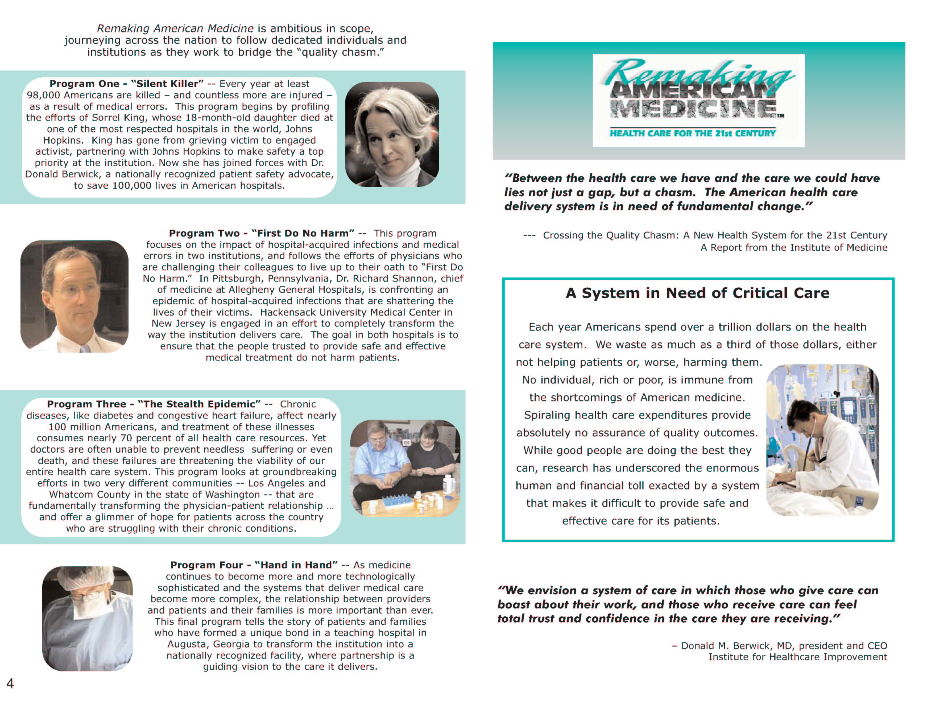
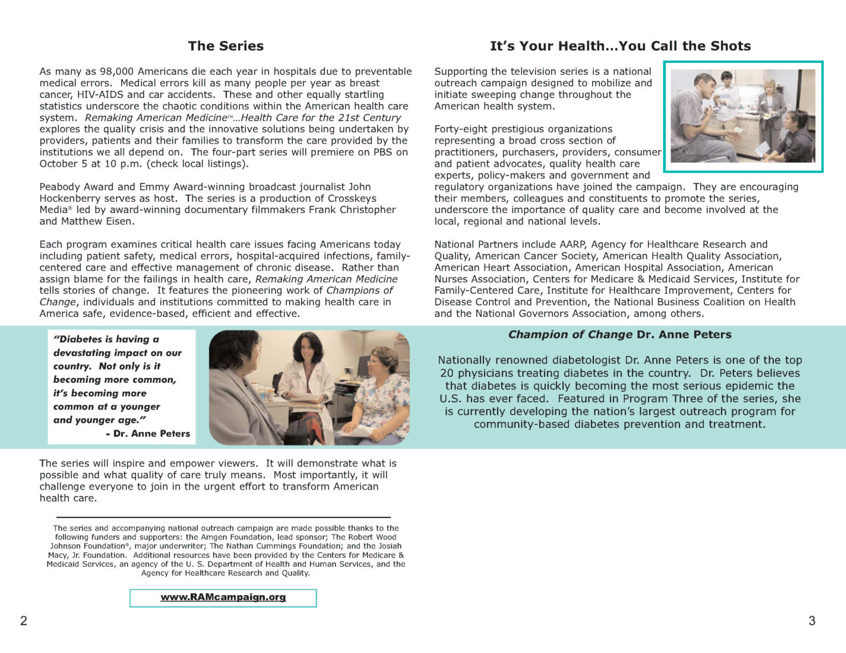

Improving Health Care – Community by Community

Here are ways you can find out more about improving health care quality in your community. (Use this space to list public activities your coalition is planning. Examples may include Town Hall meetings, health care forums, screenings, and discussion groups. Be sure to include a Web site address for more information as well. You may also want to include the titles of any consumer publications you have produced for your campaign and how people could access these.)

For further information contact: (your point of contact here with telephone, organization name and email address if appropriate.)

